
IDS TRANSFER STOCK

Estate Descriptions

General Needs

- This leaflet gives a brief description of all IDS’ general needs housing stock that is available for transfer applicants.

- It will also give you an estimate of how long it will take to reach the top of a particular waiting list. This is only a guide. We are unable to guarantee future stock availability.

- You can list as many schemes that have appropriately sized accommodation as you wish on your transfer application.

- The more schemes you are prepared to consider the quicker you will reach the top of the waiting list.

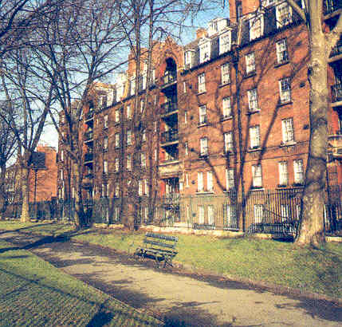.
LONDON BOROUGH OF HACKNEY  Evelyn Court, Amhurst Road, London E8  This estate has 320 flats made up of two and three bedroom units. There are no lifts. It has a children’s playground, a walled games court, a launderette, a community hall, a toddlers group and an after school scheme. There is an active tenants association. There is also limited allocated parking. There is an Estate Manager and three Resident Caretakers.  Estimated waiting time:  1 bedroom 5 years 2 bedroom 3 Years  3 bedroom 4 Years 4 bedroom 6 years | 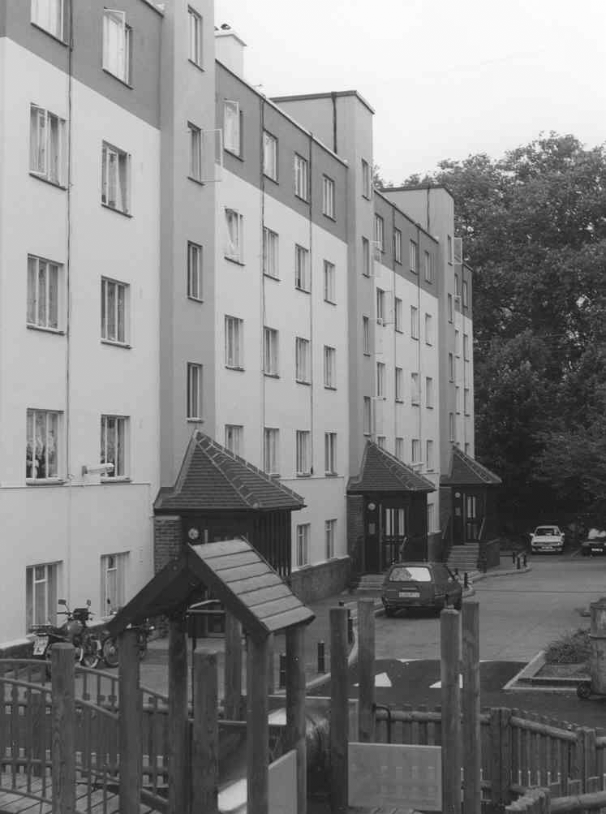
Nathaniel Court, Green Lanes, London N4  This scheme is designed for Jewish applicants only.  This block has 23 three-bedroom flats and a two bedroom flat. It is on five floors and has a lift. Estate management and caretaking services are covered by Stoke Newington Estate staff.  Estimated waiting time:  2 bedroom N/A 3 bedroom 5 Years | 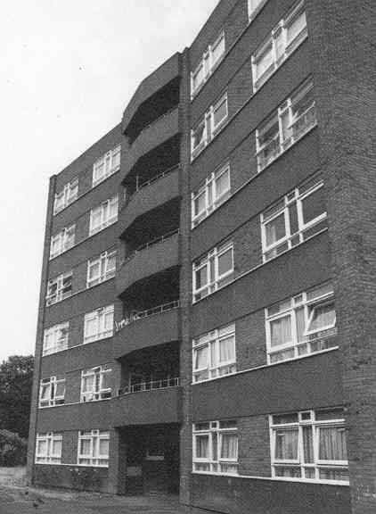
Navarino Mansions, Dalston Lane, London E8  This estate has 209 flats. The majority are one bedrooms but there are 37 two-bedrooms, 21 three-bedrooms and 2 four-bedroom flats. There are five floors and each block has a lift. There is a Community Hall and the estate is close to Hackney Downs station and local amenities. There is an Estate Manager and 3 Resident Caretakers. The waiting lists for a transfer to this estate are very long.  Estimated waiting time:  1 bedroom 5 Years 2 bedroom 10 Years  3 bedroom 15 Years 4 bedroom N/A Years | 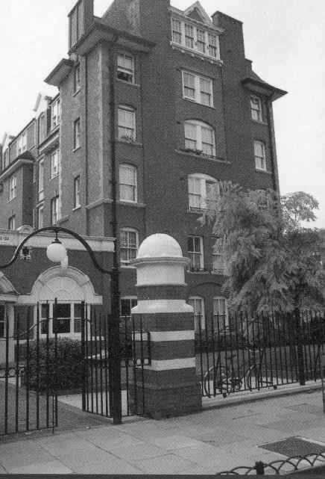
Stoke Newington Estate, Victorian Road, London N16  This estate is made up of two avenues, Imperial and Coronation. There are 273 flats: 167 one-bedroom and bedsits; 89 two-bedroom and 17 three-bedroom flats. There is a Community Hall and all tenants have free access to the UK Online Centre. This estate is very convenient for local shops and transport. There is a Resident Estate Manager and three Resident Caretakers.  Estimated waiting time:  1 bedroom 3 Years 2 bedroom 8 Years  3 bedroom 15 Years | 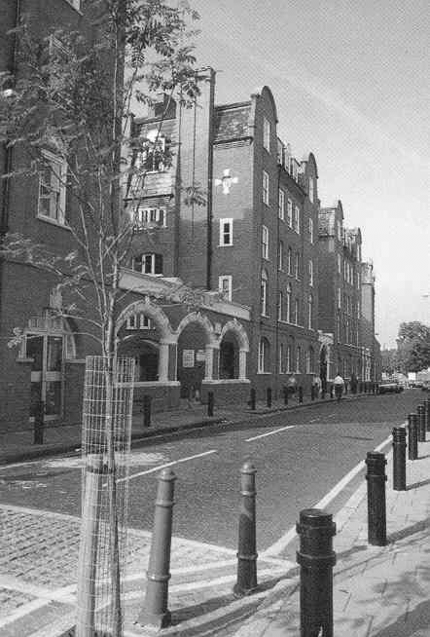
LONDON BOROUGH OF TOWER HAMLETS  Stepney Green Court, Stepney Green, London E1  This estate has 92 flats, 45 one and 45 two-bedroom flats. There are also 4 four-bedroom maisonettes. There are five floors and each block has a lift. There is a community hall and a launderette. The estate is in a quiet location but is close to Stepney Green tube station. Estate Management duties are shared with the Evelina Mansions Manager. There are two Resident Caretakers.  Estimated waiting time:  1 bedroom 8 Years 2 bedroom 6 Years  4 bedroom 15 Years | 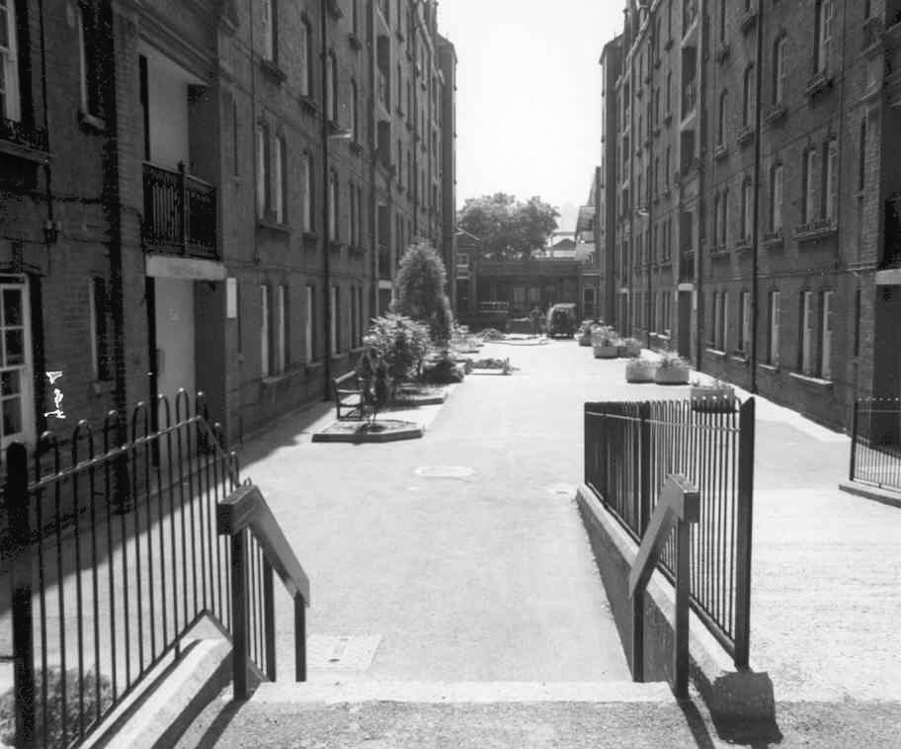
Mocatta House, Brady Street, London E1  This block has 19 one-bedroom flats and one bedsit. It has five floors but there is no lift. It is very central and is a short walk from the London Hospital and Whitechapel tube and market. Estate management and caretaking services are covered by Stepney Green Court staff.  Estimated waiting time:  1 Bedroom 3 Years | 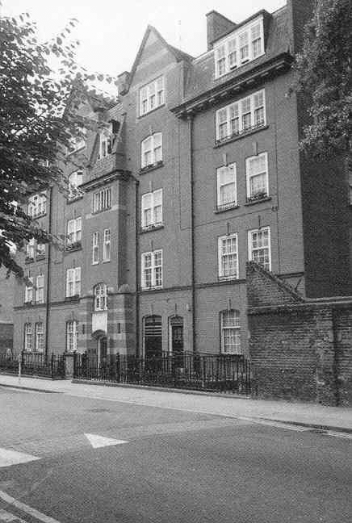
Rebecca House, Brokesley Street, London E3  This block has 33 flats; 7 bedsits; 13 two-beds; 12 three-beds and 1 four-bedroom flat. It is on 5 floors and is unlifted. It is situated in a quiet cul-de-sac and is a short walk from Mile End tube station. Estate management and caretaking services are covered by Stepney Green Court staff.  Estimated waiting time:  Bedsit 1 Year 2 bedroom 5 Years  3 bedroom 8 Year 4 bedroom N/A | 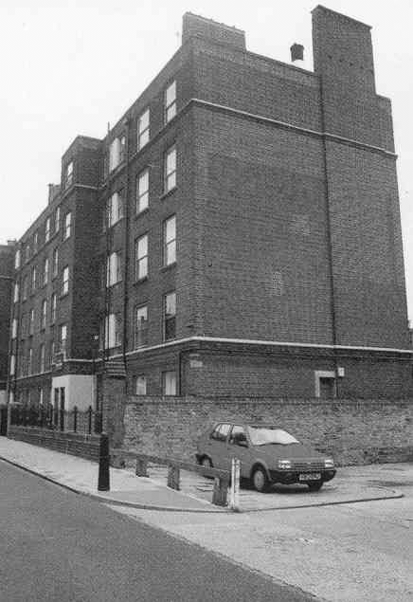
LONDON BOROUGH OF SOUTHWARK  Evelina Mansions, New Church Road, Camberwell, London SE5  A small estate, convenient for local services and close to bus services.  There are 72 flats made up of one and two-bedrooms over five floors. Each block has a lift. It is next to another IDS property, Leslie Prince Court, and shares the services of a Resident Estate Manager and Resident Caretaker. There is a community hall and an active tenants association.  Estimated waiting time:  1 bedroom 5 Years 2 bedroom 5 Years | 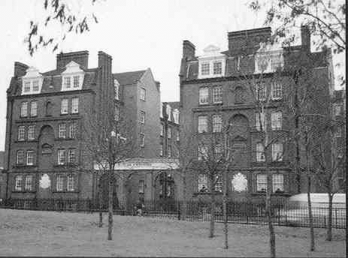
Leslie Prince Court, New Church Road, Camberwell, London SE5  This small block has 11 flats: 6 one-bedroom, 4 two-bedroom and 1 four-bedroom flat. It has three floors and is un lifted. It shares all estate services with Evelina Mansions.  Estimated waiting time:  1 bedroom 10 Years 2 bedroom 6 Years  4 bedroom N/A | 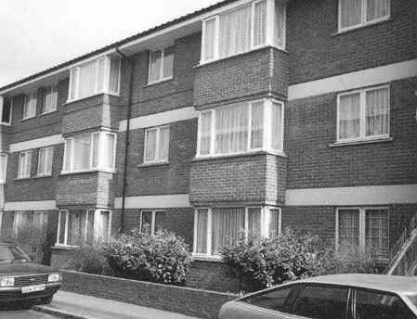

TRANSFER STOCK STATISTICS

General Needs Accommodation – All flats are self contained and centrally heated.
ESTATE | No of flats | No of floors | Lift  Y/N | Bedsit | 1 Bed | 2 Bed | 3 Bed | 4 Bed
Evelina Mansions | 70 | 6 | Y | 2 | 46 | 22 | - | -
Evelyn Court | 317 | 5 | N | - | 11 | 173 | 129 | 4
Leslie Prince Court | 11 | 3 | N | - | 6 | 4 | - | 1
Mocatta House | 20 | 5 | N | 1 | 19 | - | - | -
Nathaniel Court | 24 | 6 | Y | - | - | 1 | 23 | -
Navarino Mansions | 209 | 5 | Y | - | 149 | 37 | 21 | 2
Rebecca House | 33 | 5 | N | 7 | - | 13 | 12 | 1
Stepney Green Court | 92 | 5 | Y | - | 45 | 43 | - | 4
Stoke Newington Estate | 273 | 5 | N | 32 | 135 | 89 | 17 | -
TOTAL STOCK | 1049 |  |  | 42 | 411 | 382 | 202 | 12

